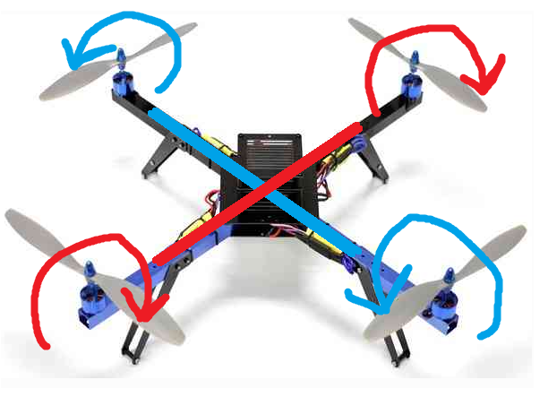

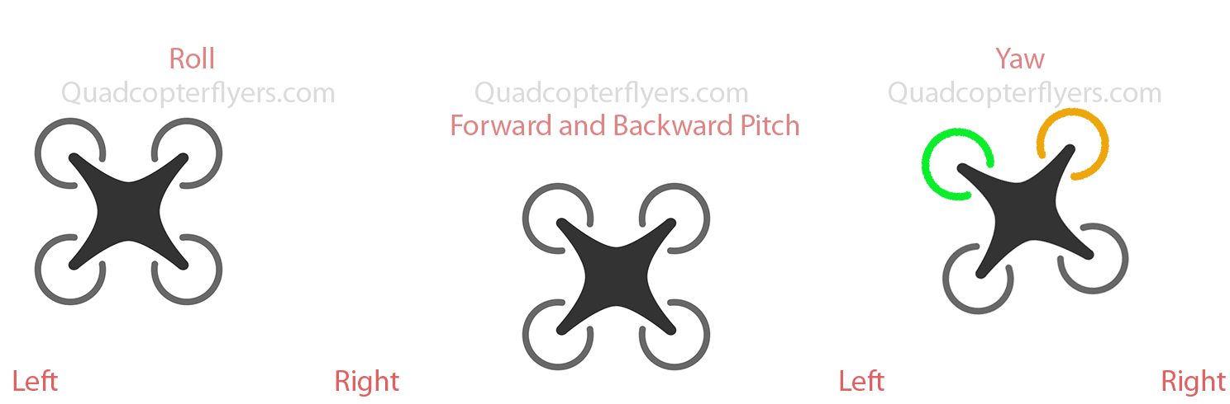

**Stabilize Mode** which provides inertial stabilization and permits manual flight control.

**In Loiter Mode** the Copter automatically maintains position and altitude but permits manual override.

**Wander Mode** allows for the drone to move in a sporadic and erratic manner within ½ sq meter with appropriate altitude

**Simple Mode** enables the copter to be flown without regard to the copters orientation (the direction it is facing).

**“Auto Land**” causes the copter to descend and disarm its motors when it has landed

Things needed:

* 6+ channel RC transmitter and receiver
* Frame
* Motors
* ESCs
* Propellers
* Autopilot hardware with (recommended):
  + An SD card for logging, terrain data base, scripting (if desired)
  + Sufficient outputs for the number of motors and servos to be used
  + Sufficient number of UARTs for GPS, and telemetry radios, if desired
  + Vibration isolated IMU(s) is very desirable simplifying mounting considerations.
  + Be sure the autopilot includes a barometer
  + I2C for external compass
* GPS module
* LiPo batteries and charger (modular system for slip in and out; include BMS)
* Ground Control Station. Ex: Mission Planner
* Telemetry Radio

SAFETY RULES:

* Nah (yeah screw these)

How to build: <https://ardupilot.org/copter/docs/build-your-own-multicopter.html>

Physics: 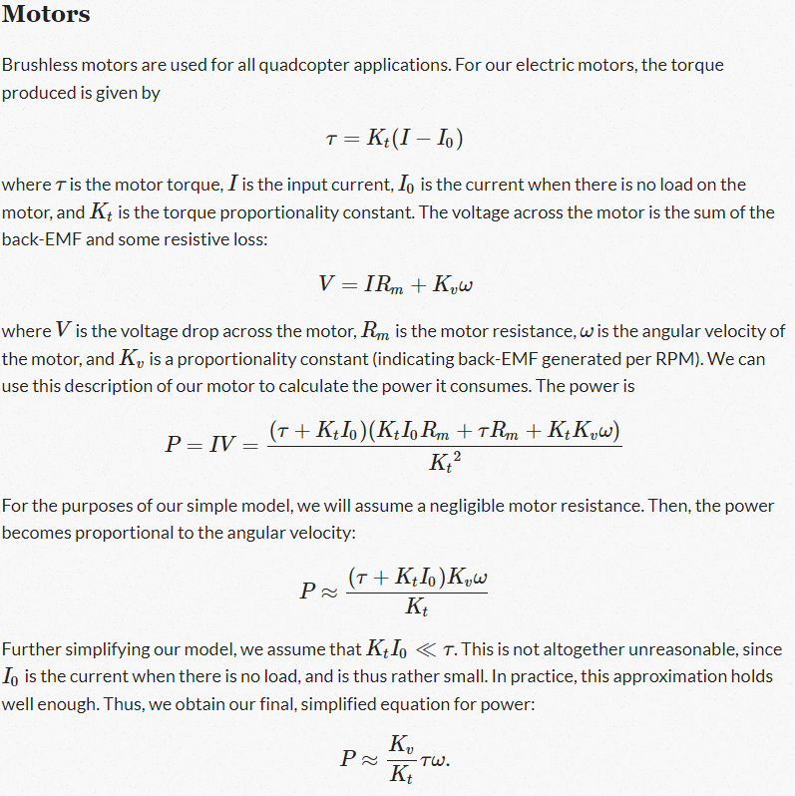

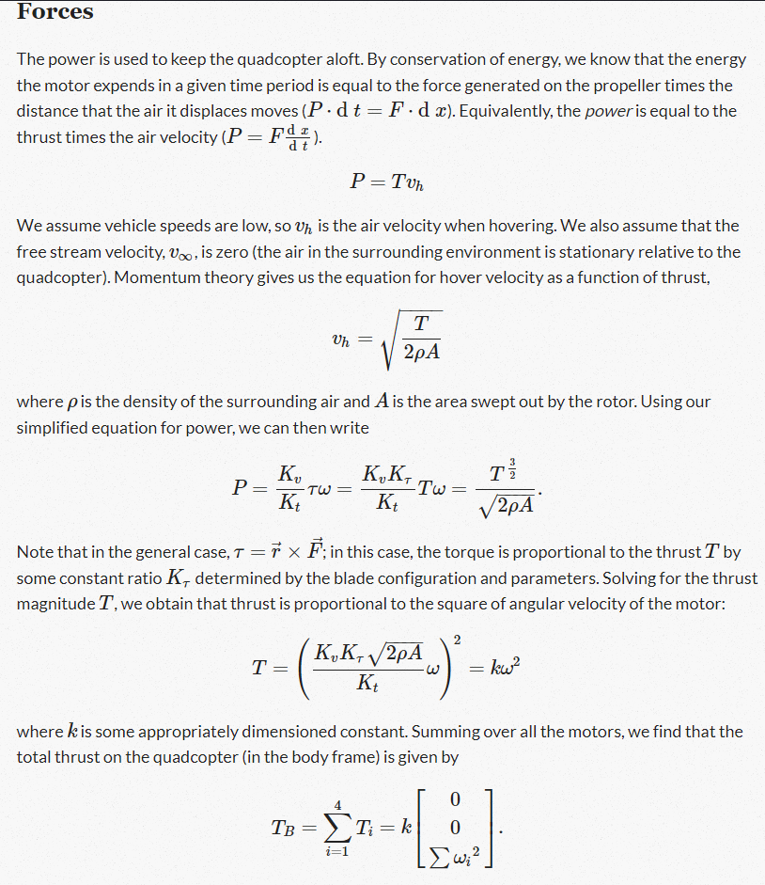

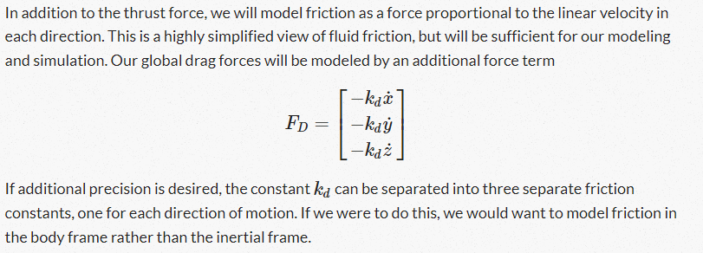

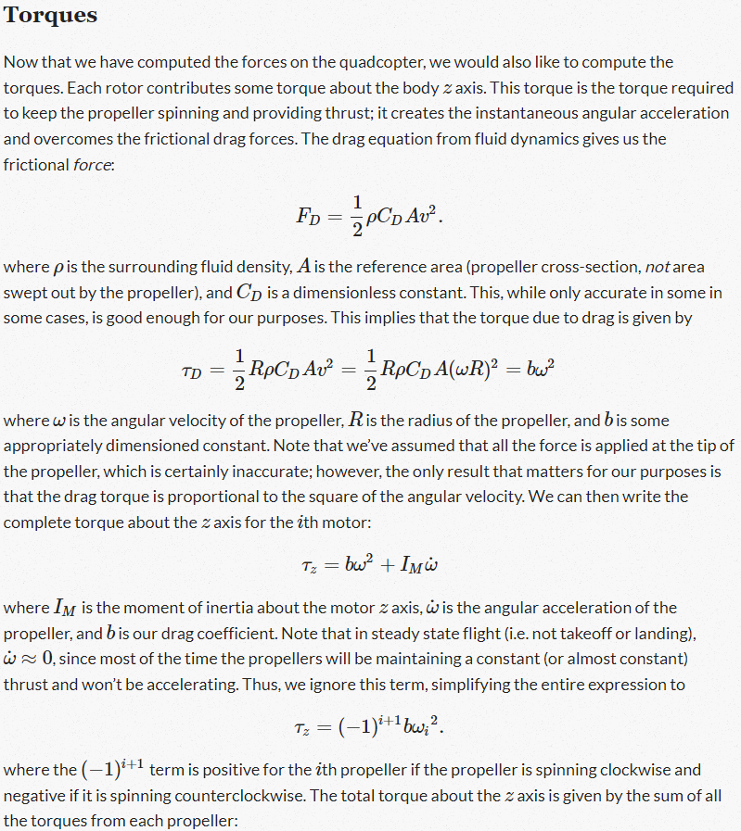

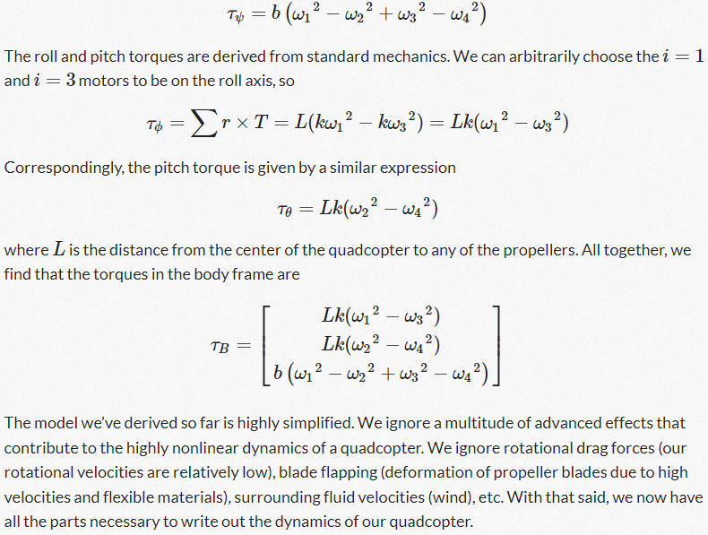

<https://robotics.stackexchange.com/questions/7460/how-to-calculate-quadcopter-lift-capabilities>

VERY GOOD: <http://ffden-2.phys.uaf.edu/webproj/211_fall_2018/J-Rod_Maltos/physics_4th.html#:~:text=The%20Rotors%20on%20the%20quadcopter,the%20quad%20hovers%20in%20midair>.

Let’s say:

2 kg drone

Max thrust per motor 775g

4*.775-2=1.1 kg not too bad

Chat GPT is the GOAT

Total Weight:

1. 1 lbs payload (medical supplies) x1
2. Drone Frame x1
3. Motor x 4
4. Electronics System x1
5. Battery x1

Front Camera (front)

PIR sensor (bottom)

Battery bay (back)

Internal Components (12.7x5.08cm)

4 motors

Retractable landing gear (optional)

3d DESIGN

Material: ABS